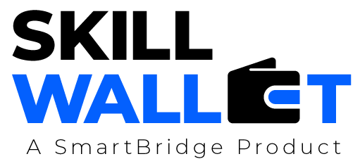

Scalability & Future Plan

Date | 01 July 2026
Team ID | XXXXXX
Project Name | OptiCrop: Smart Agricultural Production Optimization Engine
Maximum Marks | 1 Mark

Scalability & Future Plan:

Current System Limitations:
S.No | Limitation | Impact | Priority to Address  (High / Medium / Low)
1 | Limited dataset size | May reduce prediction accuracy for unseen conditions | High
2 | Single-user deployment | Cannot support many concurrent users | Medium
3 | Basic security mechanisms | Risk of unauthorized access | HIgh

Scalability Plan:
S.No | Scalability Aspect | Current State | Proposed Upgrade / Solution
1 | User Load | Supports limited users | Deploy on cloud with load balancing
2 | Data Storage | Local dataset | Use cloud database and scalable storage
3 | Performance | Basic ML prediction | Optimize model and enable caching
4 | Security | Simple authentication | Add JWT, HTTPS and role-based access

Future Roadmap:

Phase | Planned Feature / Enhancement | Target Timeline | Expected Impact
Phase 1 | Increase dataset and retrain ML model | 1-2 Months | Improved prediction accuracy
Phase 2 | Mobile application for farmers | 3-4 Months | Better accessibility
Phase 3 | IoT sensor integration | 5-6 Months | Real-time recommendations
Phase 4 | Satellite & weather API integration | 6-12 Months | Highly accurate smart farming support

